Teknik Decomposition Multiplicative Sayuran Buncis

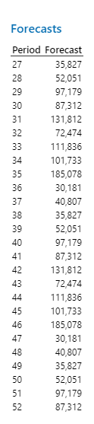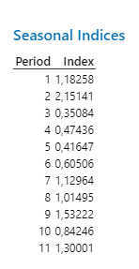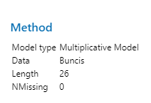

Rincian biaya tetap dan biaya tidak tetap sayuran buncis

1. Biaya tetap

|  |  |  |  |  |
| --- | --- | --- | --- | --- |
| No. | Jenis Biaya | Banyaknya | Satuan | Harga (Rp) |
| 1. | Listrik | 1 | Bulan | 750.000 |
| 2. | Bensin | 1 | Bulan | 100.000 |
| 3. | Pemeliharaan Alat | 2 | Alat | 10.000 |
| 4. | Penyusutan Alat | 2 | Alat | 4.167 |
| 5. | Tenaga Kerja | 1 | Orang | 300.000 |
| 6. | Biaya Lainnya | 1 | Bulan | 500.000 |

Sumber : PT. Tiga Bintang Sukses, 2022

1. Biaya tidak tetap

|  |  |  |  |
| --- | --- | --- | --- |
| No. | Jenis Biaya | Volume (Kg) | Harga (Rp) |
| 1. | Kemasan | 1 | 500 |
| 2. | Buncis | 1 | 7.000 |
| 3. | Brokoli | 1 | 12.000 |
| 4. | Kol Putih | 1 | 5.000 |
| 5. | Sawi Putih | 1 | 6.000 |
| 6. | Wortel | 1 | 7.000 |
| 7. | Selada Hijau | 1 | 15.000 |

Sumber : PT. Tiga Bintang Sukses, 2022

Hasil perhitungan ramalan keuntungan buncis

|  |  |  |  |  |  |  |
| --- | --- | --- | --- | --- | --- | --- |
| **NO** | **Bulan** | **Minggu** | **Total Penerimaan** | **Total Biaya** | **Keuntungan** | **Keuntungan per bulan** |
|
| 1 | 1 | 1 | 465.790 | 298.230 | 167.560 | 1.890.157 |
| 2 | 2 | 676.650 | 433.237 | 243.413 |
| 3 | 3 | 1.263.340 | 808.876 | 454.464 |
| 4 | 4 | 1.135.030 | 726.723 | 408.307 |
| 5 | 5 | 1.713.530 | 1.097.118 | 616.412 |
| 6 | 2 | 6 | 942.110 | 607.523 | 334.587 | 2.175.118 |
| 7 | 7 | 1.453.920 | 937.565 | 516.355 |
| 8 | 8 | 1.322.490 | 852.812 | 469.678 |
| 9 | 9 | 2.406.040 | 1.551.543 | 854.497 |
| 10 | 3 | 10 | 392.340 | 305.384 | 86.956 | 457.743 |
| 11 | 11 | 530.530 | 412.946 | 117.584 |
| 12 | 12 | 465.790 | 362.555 | 103.235 |
| 13 | 13 | 676.650 | 526.681 | 149.969 |
| 14 | 4 | 14 | 1.263.340 | 793.461 | 469.879 | **2.420.522** |
| 15 | 15 | 1.135.030 | 712.873 | 422.157 |
| 16 | 16 | 1.713.530 | 1.076.210 | 637.320 |
| 17 | 17 | 942.110 | 591.707 | 350.403 |
| 18 | 18 | 1.453.920 | 913.157 | 540.763 |
| 19 | 5 | 19 | 1.322.490 | 881.264 | 441.226 | 1.551.858 |
| 20 | 20 | 2.406.040 | 1.603.307 | 802.733 |
| 21 | 21 | 392.340 | 261.443 | 130.897 |
| 22 | 22 | 530.530 | 353.528 | 177.002 |
| 23 | 6 | 23 | 465.790 | 323.455 | 142.335 | 1.081.993 |
| 24 | 24 | 676.650 | 469.881 | 206.769 |
| 25 | 25 | 1.263.340 | 877.291 | 386.049 |
| 26 | 26 | 1.135.030 | 788.190 | 346.840 |

Sumber : Data Sekunder (diolah), 2022